WORKBOOK ASSIGNMENT – 3

QUESTION1
Q1) Create a database named JuniorCollegeDB and a table named Student. The table should contain the following columns: Column Name Data Type Constraint StudentID INT PRIMARY KEY StudentName VARCHAR(50) Age INT Course VARCHAR(30) City VARCHAR(30) Marks INT Email VARCHAR(60) Insert at least 10 records into the table. Some records should contain NULL values in the Email column.
Ans: Query:
CREATE DATABASE JuniorCollegeDB;
USE JuniorCollegeDB;

CREATE TABLE Student (
StudentID INT PRIMARY KEY,
StudentName VARCHAR(50),
Age INT,
Course VARCHAR(30),
City VARCHAR(30),
Marks INT,
Email VARCHAR(60)
);

INSERT INTO Student (StudentID, StudentName, Age, Course, City, Marks, Email)
VALUES
(1, 'Aarav Shah', 18, 'BSc IT', 'Mumbai', 85, 'aarav@email.com'),
(2, 'Meera Joshi', 19, 'BCA', 'Pune', 75, NULL),
(3, 'Rohan Patil', 20, 'BSc IT', 'Nashik', 92, 'rohan@email.com'),
(4, 'Ananya Desai', 19, 'BSc', 'Mumbai', 81, 'ananya@email.com'),
(5, 'Karan Mehta', 21, 'BCA', 'Pune', 68, NULL),
(6, 'Neha Sharma', 18, 'BSc IT', 'Mumbai', 88, 'neha@email.com'),
(7, 'Aditya Verma', 20, 'BSc', 'Nashik', 72, NULL),
(8, 'Priya Singh', 19, 'BCA', 'Pune', 95, 'priya@email.com'),
(9, 'Rahul Rao', 21, 'BSc IT', 'Mumbai', 79, 'rahul@email.com'),
(10, 'Sneha Iyer', 20, 'BSc', 'Nashik', 84, NULL);
Output:
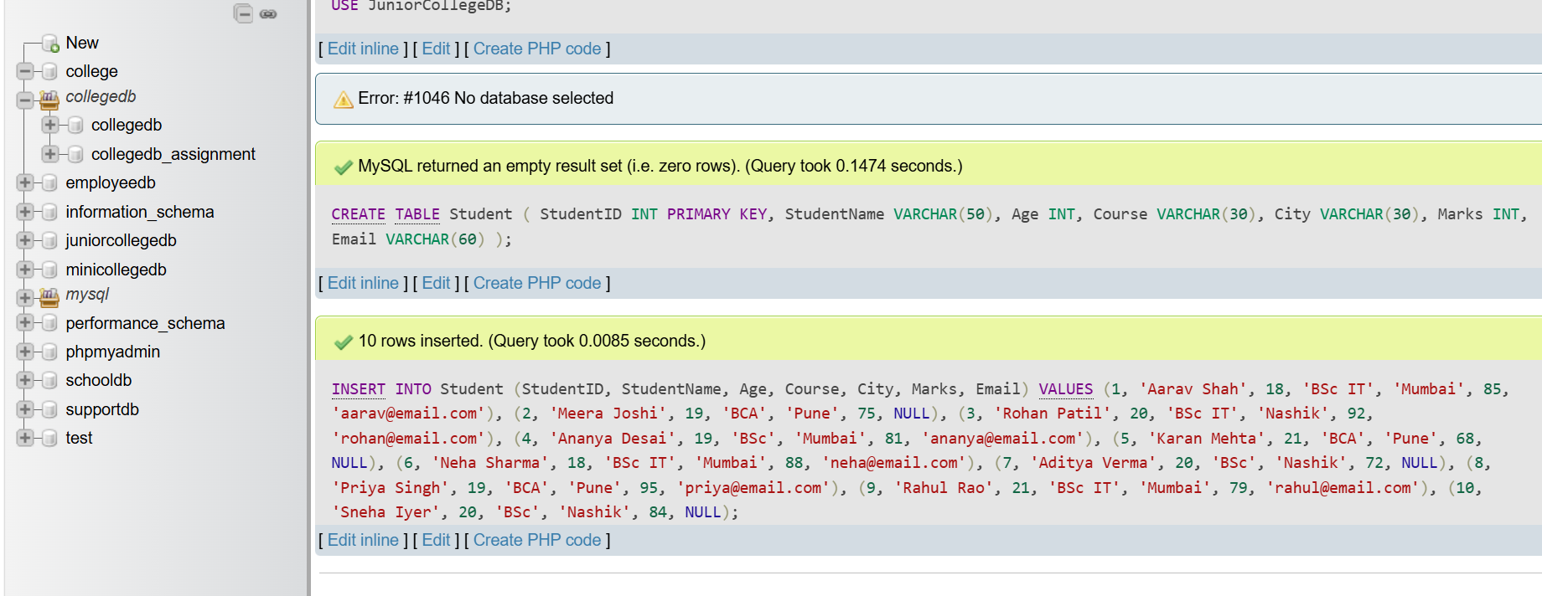

QUESTION2
Q2) Write a MySQL query to display students who are from Mumbai and have marks greater than 80. The output should include
Column
StudentID
StudentName
City
Marks
Ans: Query:
SELECT StudentID,
StudentName,
City,
Marks
FROM Student
WHERE City = 'Mumbai'
AND Marks > 80;

Output:
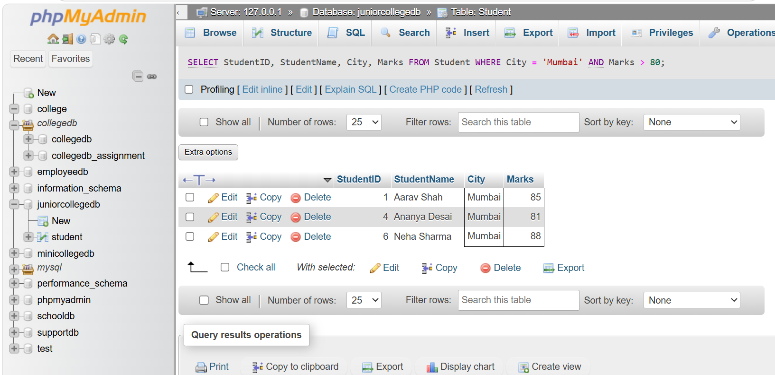
QUESTION3
Q3) Write a MySQL query to display students who belong to either Pune or Nashik. Use the OR operator and display the following columns:
Column
StudentName
Course
City
Ans: Query:
SELECT StudentName, Course, City
FROM Student
WHERE City = 'Pune' OR City = 'Nashik';
Output:
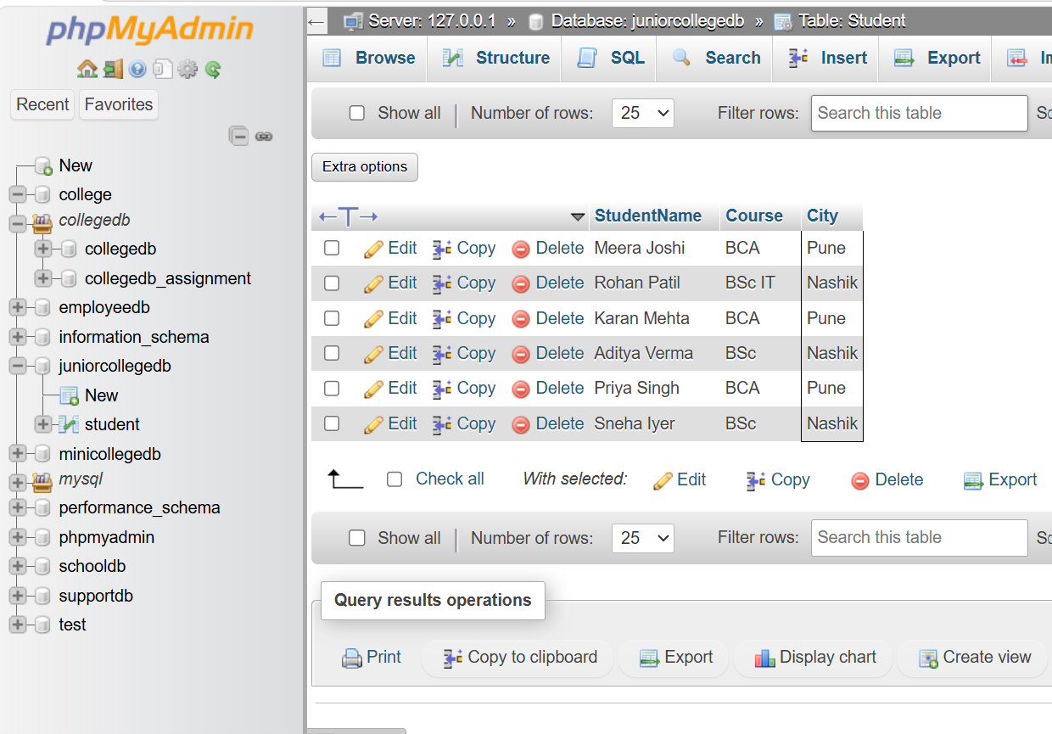

QUESTION4
Q4) Write a MySQL query to display students whose marks are between 70 and 90. Use the BETWEEN operator and display:
Column
StudentName
Marks
Ans: Query:
SELECT StudentName, Marks
From Student
Where Marks BETWEEN 70 AND 90;
Output:
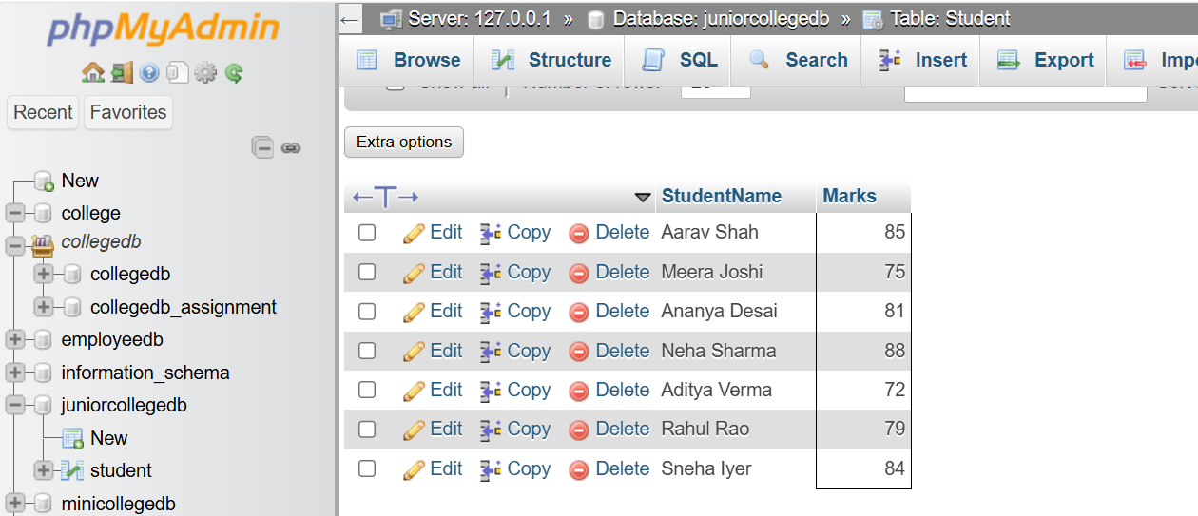
QUESTION5
Q5) Write a MySQL query to display students whose names start with the letter A. Use the LIKE operator and display:
Column
StudentID
StudentName
Ans: Query:
SELECT StudentID, StudentName
FROM Student
WHERE StudentName LIKE 'A%';

Output:
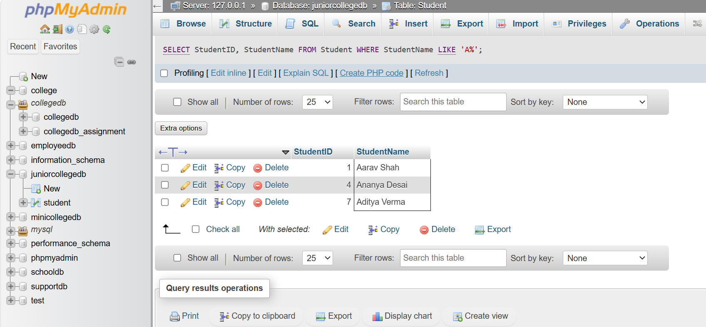
QUESTION6
Q6) Write a MySQL query to display students whose email address is missing. Use the IS NULL operator and display:
Column
StudentID
StudentName
Email
Ans: Query:
SELECT StudentID, StudentName, Email
From student
Where Email IS NULL;
Output:
